

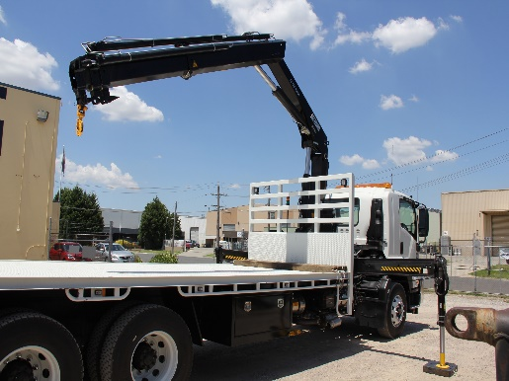
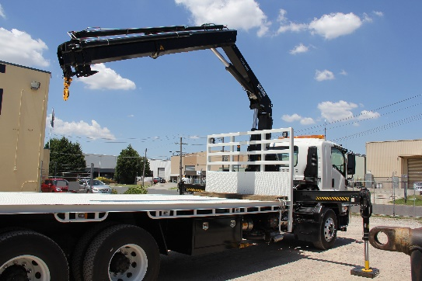

RTO 4575

Brochure for Pre-enrolment information
(CV) Vehicle Loading Crane (Capacity 10mt tonne and above)
Training and Assessment (5 days)
TLILIC0024 Licence to operate a vehicle loading crane (capacity 10mt tonne and above)
Course Objective
To provide applicants with the practical skills and knowledge to safely operate a Vehicle Loading Crane (capacity 10mt tonnes and above (CV) in accordance with Safe Work Australia’s National Standard for Licencing Persons Performing HRW. All training and assessments are carried out by our own HRW trainers and assessors certified by Worksafe Victoria.
Course Prerequisites
- Applicants must be 18 years of age to undertake the training and assessment
- Ability to read, write, speak, and understand basic English
- Applicants must understand basic mathematics which includes the use of formulas
Note: RPL pathway is not available for this course due to licencing requirements. Applicants are required to complete the full training course. Refer to RTO Condition 4.7 for conducting assessments.
Booking Information
Online Booking: www.australianeasytrain.com.au
Email: courses@auseasytrain.com.au
Phone: (03) 9706 4881 Fax: (03) 9706 4882
Address: 35 Kimberly Road Dandenong South 3175
Student Handbook: Information and all terms & conditions available at:
www.australianeasytrain.com.au

Training Methods
Knowledge
- Face to Face Classroom, training knowledge course guide, with the use of white board, DVD’s, samples of equipment, simulated workspace and or roll play.
- Questioning, observation, working through student workbooks, course assessment.
Performance
- Trainer to demonstrate full hazard identification of performance area, risk controls to ensure a safe working environment.
- Demonstration of the performance criteria for the safe operation of a vehicle loading crane in accordance with the Australian Standards by trainer and student.

Course Outcomes
On successful completion of the course assessment applicants will be issued with a:
- Nationally Accredited Statement of Attainment
On successful completion HRWL assessment applicants will be issued with a:
- Notice of Satisfactory Assessment (NOA)

RTO 4575



Brochure for Pre-enrolment information
TLILIC0024 Licence to operate a vehicle loading crane (capacity 10mt tonne and above)
Start Time | 7:45 for 8am Start.
Course Duration | 5 Days x 8 Hours
Cost | $2400. No GST Applies
Course Content | - Plan work/task  - Prepare for work/task  - Perform work/task  - Pack up
Fees Include | - Vehicle Loading Crane Course Learner Guide  - Materials and Equipment  - Training and Assessment
Worksafe Fees | - Additional licencing fee is payable to Worksafe Victoria within 60 days of assessment online through your myworksafe account  - Further information about your application and the related fees can be found on the Worksafe website:  worksafe.vic.gov.au or call 1300 852 562
Location | 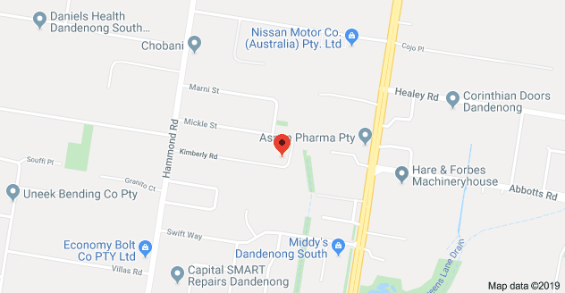  All training and assessments will be conducted at our location at 35 Kimberly Road Dandenong South 3175
PPE. (Personnel Protective Equipment) | Applicants must provide relevant PPE to participate in the course.  - Steel capped safety boots  - Hi-Visibility clothing/vest  - Hard hat  Note: All PPE must be in good condition.
Applicant Requirements | - Have Photo ID (i.e., Australian Drivers Licence, Passport, Proof of age card)  - ID must contain photo, signature, and date of birth  - Proof of Victorian residential address  - Proof of a USI Number  - Study the course material prior to attending  - Complete Pre-Course Workbook prior to attending training course  - Create a MYWORKSAFE account for licence application
Assessment Methods | Course Evidence  - Knowledge evidence - Questions  Assessments are conducted as closed book  - Performance/Observation evidence  HRWL Assessment  - Knowledge & Calculation Assessment  - Practical Assessment

